Procurement Journey
Develop Strategy

Guidance

https://www.procurementjourney.scot/route-3/route-3-develop-strategy

Strategy Document Template

Version Control

Version # | Updated By | Date Updated | Change Details

Project Plan
An example project plan which following the steps of the Procurement Journey is attached (in excel format).
Within your organisation you may use an alternative format/tool for project planning.

Stakeholder Map Template

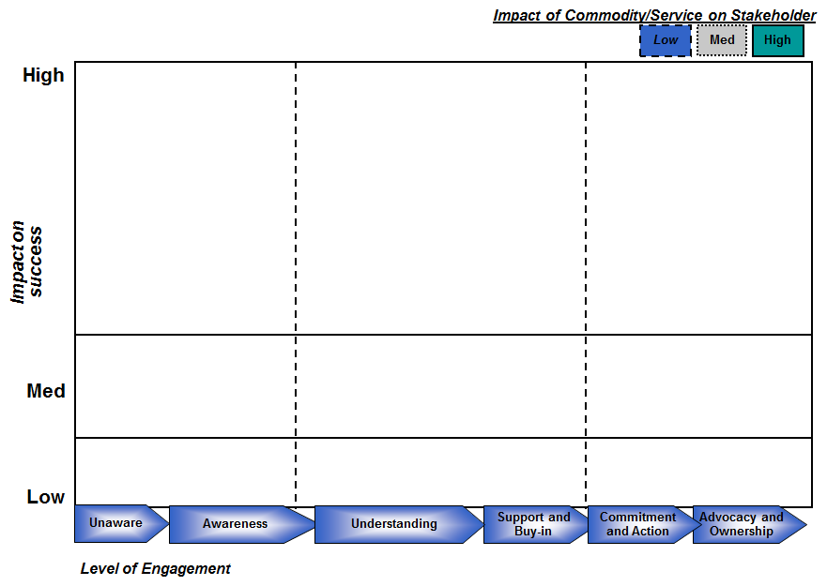

UIG Welcome Pack

It is useful to issue a Welcome Pack to members either prior to or at the initial UIG meeting. The pack includes Terms of Reference of the group along with information on roles and responsibilities, core competencies and business conduct.

UIG Charter

Group Objectives | Scope & Activities | Key Areas For Success | Measures
 |  |  | Deliverables
Milestones

UIG Membership

Add Commodity/Service Name here
Name | Location | Dept. | Role | Tel.

Current Status of Commodity/Service Contracts

1 – Commodity/Service Definition
Commodity/Service Name | Definition | Source

Current Status of Commodity/Service Contracts

2 – Current Contracts
Contract Details | Contract Scope | Expiry Date | Current Pricing

Current Status of Commodity/Service Contracts

3 – Relevant Policies/Processes
Policy Detail | Reason of Impact | Source

Spend Analysis
Create your Spend Analysis and add it here. This is an example of format.

Sustainability

Sustainability Aspects | Considerations | Actions

Social

Economic

Environmental

Classifying a Commodity/Service

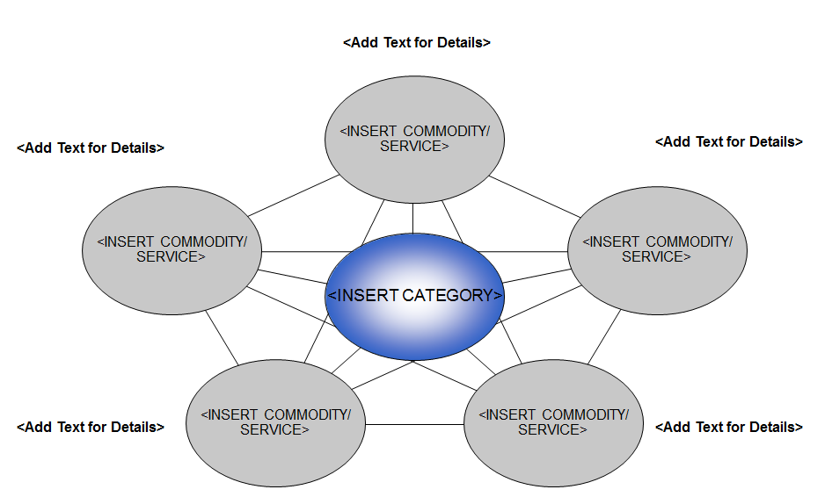
<Insert Commodity/Service>
<Insert Commodity/Service>
<Insert Commodity/Service>
<Add Text for Details>
<Add Text for Details>
<Add Text for Details>
<Insert Commodity/Service>
<Insert Commodity/Service>
<Insert Category>
<Add Text for Details>
<Add Text for Details>

Commodity/Service Tree - Example
(Convert to Service as required)
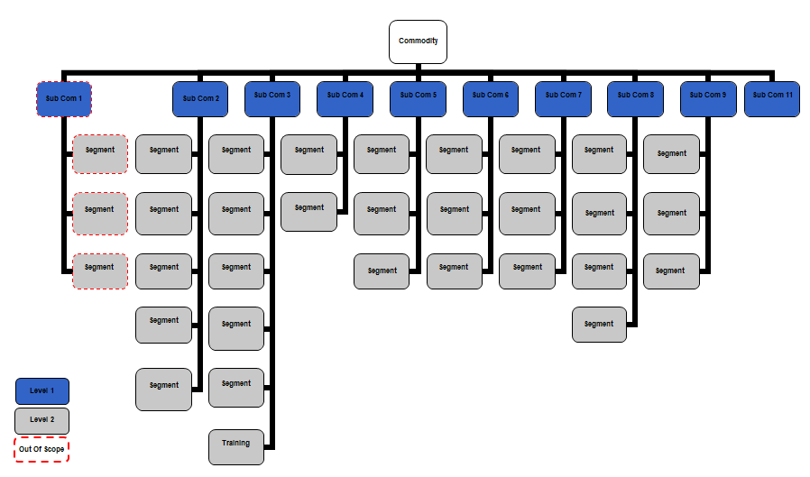

Key Commodity/Service Characteristics

Functionality | End User Requirements | Organisation Requirements | Future Trends | Contraints

Market Summary Template

Factor | Findings from Research

Market Definition

Market Overview

Trade Associations

Key Suppliers

Market Growth

Trends and Developments

Supply Market Trends

External Data Sources

Reference No. | Source | Dated | Web Address
1) | <Add source/report title> | <Add date of report/article/quote> | <Add website address for future reference>
2)
3)
4)
5)
6)
7)

Risk Register

Project Name/Contract Title |  |  |  | Risks identified as at -
Risk ID | Risk Owner | Description of Risk | Probability/Impact Result |  | Date of Assessment | Mitigating Actions | Next Review Date

Supplier Profile Analysis
X Supplier is the global leader in the provision of Y solutions

Organisation and History
Strategy and Key Market Segments

Product, Service Range and Operations
Key Financials and Other Developments

Insert commodity/service specific Supplier Data. Use 1 slide for each of the top 5 suppliers.
You should base the top 5 on whether you think the market is global, European, or UK only.

Porter’s 5 Forces – Competitive Positioning

Threats and Substitutes
- <Add Comment>

Competition in Industry
Power of Supplier
Power of Buyer
- <Add Comment>
- <Add Comment>
- <Add Comment>

Threats of New Entrants

- <Add Comment>

SWOT Analysis

Strengths

- Text
- Text
- Text
Weaknesses

- Text
- Text
- Text

Opportunities

- Text
- Text
- Text
Threats

- Text
- Text
- Text

PESTLEE Analysis
ECONOMIC

SOCIAL-DEMOGRAPHIC
POLITICAL

PESTLEE Analysis

ETHICAL

TECHNOLOGICAL

ENVIRONMENTAL
LEGAL

Supply Market Analysis

Supplier Name | Annual Turnover in Scotland £000 | Annual Turnover in UK £000 | Current Expenditure £000 | Percentage of Turnover Scotland | Percentage of Turnover UK
Sub-Total Spend with Top 10 Suppliers

Supplier Cost Drivers

Cost Element  (e.g. Material, Labour, Sub-contract, Transport, Overheads,…) | % of Overall Price  (Use estimates, market, supplier and existing analysis) | Source of Data | Data Confidence (Low, Medium, High)

Total Cost of Ownership: Considerations

Acquisition

Ownership

Operation

Disposal

Best Value Triangle – Identifying Opportunities
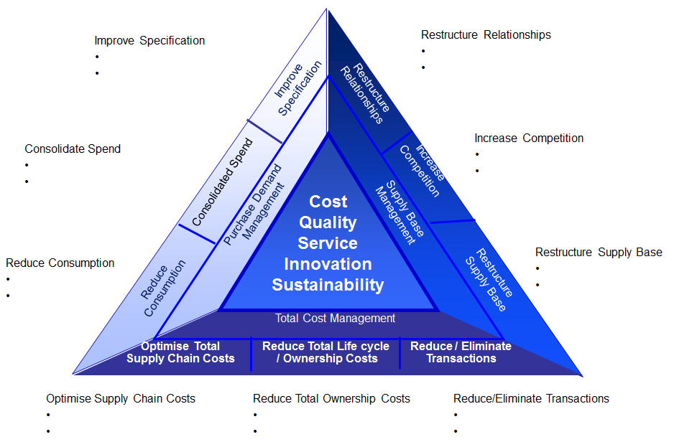
Restructure Relationships

Increase Competition

Reduce/Eliminate Transactions

Consolidate Spend

Optimise Supply Chain Costs

Reduce Total Ownership Costs

Improve Specification

Reduce Consumption

Restructure Supply Base

Best Value – Tabled Version
Improve Specification

Restructure Supply Base

Reduce Consumption

Best Value Opportunity Assessment
 |  | Description | Ease | Time | Benefits | Resources | Pros | Cons
Purchase Demand Management  “Have you considered this?” | Reduce Consumption
Purchase Demand Management  “Have you considered this?” | Consolidate Spend
Purchase Demand Management  “Have you considered this?” | Improve Specification
Supply Base Management  “Have you considered this?” | Restructure Relationships
Supply Base Management  “Have you considered this?” | Increase Competition
Supply Base Management  “Have you considered this?” | Restructure Supply Base
Total Cost Management  “Have you considered this?” | Optimise Total Supply Chain Costs
Total Cost Management  “Have you considered this?” | Reduce Total Ownership Costs
Total Cost Management  “Have you considered this?” | Reduce Transactions

Opportunity Assessment
Complete one slide for each opportunity identified using the Best Value Triangle

Opportunity Group (Link to BVT) |  |  |  | Opportunity Sub-Group (Link to BVT)
Description & Scope of Activity
Implementation |  | Resources |  | Estimate of Savings |  | Other Benefits Identified
Ease
Timing
Risks & Issues |  |  |  |  | Next Steps/Recommendation
Description | Assessment Result (Probability/Impact) | Date of Assessment | Mitigating Actions | Next Review

The Current and Future State Relationship Between Buyer & the Supplier
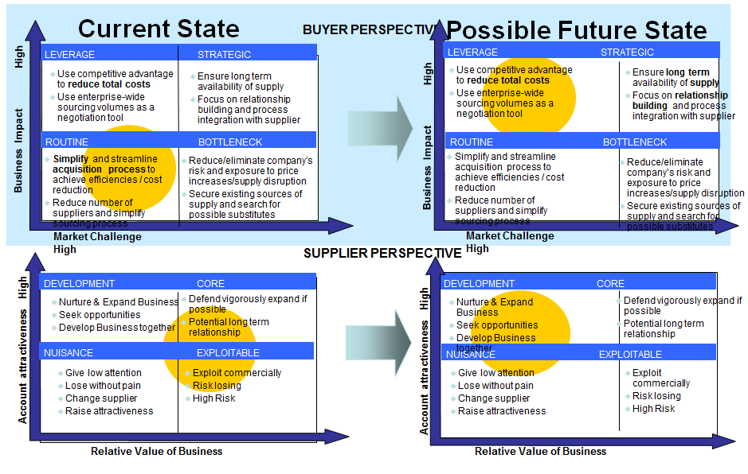

Options Decision Matrix & Summary
Complete the table below with the various options available for Procurement Route, OJEU Procedure (if applicable), Lotting Strategy and Suppliers (examples provided) and detail the benefits/concerns associated with each before recommending a preferred option with justification.

 |  | Option 1 | Option 2 | Option 3 | Option 4 | Recommendation & Justification
1. | Procurement Route | Not applicable | Do nothing | Use existing framework | Develop bespoke contract
1. | Benefits & Concerns
2. | OJEU Procedure | Open | Restricted | Competitive Dialogue | Other
2. | Benefits & Concerns
3. | Lots | Not applicable | 1 Lot | Geographical | Product/Service
3. | Benefits & Concerns
4. | Suppliers per Lot | Not applicable | 1 Supplier | 3-5 Suppliers | 5+ Suppliers
4. | Benefits & Concerns

Executive Summary
Key Findings

Benchmarking and Opportunities, Options Considered

Recommendations and Key Actions

Benefits, Justification and Projected Savings

Key Risks and Resource Implications

