Clackmannanshire Housing Strategy - Supporting Evidence

Introduction

The supporting evidence in this document follows the priorities of the Clackmannanshire Housing Strategy 2012 - 2017 and contains detailed information which helped to direct the priority outcomes. Further information can be found in the research documents listed at the end of this document.

Background Information

The following information has been taken from the Housing Need and Demand Assessment (HNDA) 2011. The HNDA is a comprehensive piece of research which covers a wide range of information and which was assessed by the Scottish Government as being 'robust and credible'.
The housing stock
- There are around 23,434 dwellings in Clackmannanshire
- Clackmannanshire Council currently owns 5,036 (21%) properties (includes 20 mortgage rescue)
- 15,360 (66%) Owner Occupied
- 1,217 (5%) Private Rented
- 1,821 (8%) Social Rented
- Social housing (Council and RSL stock) makes up around 29% of all stock in Clackmannanshire
- There is an estimated occupancy rate of around 96%, translating to around 850 empty homes.

Source: Clackmannanshire Council Property Database (2009)
Owner occupied sector
- The private sector house condition survey 2009 stated that 6.5% of private sector housing was Below Tolerable Standard (BTS), and that 73.4% failed the SHQS
- Owner occupation dominates the Clackmannanshire housing system, with two thirds, (66%) of all housing being privately owned
- The Scottish Household Survey suggests that around 39% of owner occupiers are over 60, while only 11% are under the age of 35.
Private rented sector
- The 2009 private sector stock condition survey suggests that nearly 44% of all head of households in the private rented sector are under 34, compared to only 11% in owner occupation
- Around 44% of private rented households have been resident for less than a year, which indicate a transient market
- The 2009 private sector stock condition survey found that 5% of private lets were Below Tolerable Standard (BTS). 74% are not SHQS compliant.
Social rented sector
- There were 6,857 socially rented houses in Clackmannanshire at January 2009. 74% local authority stock, 26% housing association stock. Overall, the sector accounts for 29% of the total stock of the area
- Demand for local authority stock remains high. At September 2012, there were 1,996 people on the Council waiting list
- Demand for social housing far exceeds supply. There is particular pressure on small, 1 bedroom properties and for larger 4 bedroom properties.
Market activity
- House prices are highest in the Dollar area, with average prices in 2009 being £275,000, compared to a Clackmannanshire average of £138,500
- As Clackmannanshire is a sub market of Stirling, there is evidence of inward migration from Stirling to Clackmannanshire (especially for new build housing)
- There was a strong price growth across all of Clackmannanshire over the 5 year period prior to the 2008 market downturn. Average house prices rose by 83% between 2003 and 2007 from £79,400 to £145,272. House prices have been dropping by around 2% annually to £142,272 in 2008 and to £138,452 in 2009
- The numbers of homes being sold on the open market has dropped since 2007
- First time buyers are being excluded from the market, as they require to save a minimum cash deposit of 25%.
The local economy
Clackmannanshire has some significant differences across the area in terms of economic prosperity. There are several communities, such Alloa South and East, Hawkhill, part of Clackmannan, Sauchie and Newmills, experiencing significant levels of deprivation across a number of indicators.
Some key features of the local economy include:
- The average household income of households in Clackmannanshire was estimated at £32,472 per annum in 2008 (compared with £33,220 for Scotland)
- Unemployment rates in Clackmannanshire in 2010 have been on average around 5.5%. This is compared to 4.6% across Forth Valley and 4.5% for Scotland
- The area with the highest rate of unemployment in Clackmannanshire is Alloa Mar, with an average rate of 11.5% unemployed, compared to only 1.8% in Dollar.

Population and Household
- The population in Clackmannanshire was in decline from 1995 until 2003, when it was around 47,680, and has since grown by almost 6% to 50,480 in 2008
- There are currently 22,620 households in Clackmannanshire with an average household size of 2.18. This is projected to drop to only 1.91 by 2033
- The profile of the population is expected to change over the next 25 years. The percentage of people aged 30-59 is projected to decline, from 55% to 45%, while the number of people aged 60 and over is expected to increase substantially. Over 60's will account for 40% of the population by 2033.
Homelessness
- Homeless applications peaked in 2005/06 at 1,157. The long term trend since then has seen an overall reduction of 39% over seven years to 710 in 2011/12
- The majority of homeless applicants are single people, around 50 - 60% of all applicants fall into this category
- Of the 708 applications received in 2010/11, 537 (76%) were assessed as homeless.

New Housing Supply

Annual Affordable Housing Need in Clackmannanshire (10 year average)

Annual Figures | 2008 GROS Projections
Households in need (annual backlog housing need from waiting lists) |  | 203
Newly arising annual need (new households) | + | 730
Total annual need | = | 933
Supply from stock turnover | - | 479
Annual net housing need (excluding new build and other purchases) |  | 454
Source: HNDA

Information from the HNDA indicates that Clackmannanshire has a need for more than 450 new affordable homes every year.

RSL New build Completions by Financial Year

02/03 | 03/04 | 04/05 | 05/06 | 06/07 | 07/08 | 08/09 | 09/10 | 10/11 | 11/12
28 | 58 | 20 | 27 | 42 | 0 | 1 | 64 | 64 | 2
Source: Scottish Government Housing Investment Division: Affordable Housing Investment Programme

Over the past 10 years, affordable housing has made up only 11% of the total newbuild completions, falling far short of what has been needed.

Private New build Completions by Financial Year

The supply of private housing over the past few years has dropped off dramatically due to the downturn in the economy and the knock-on effect this has had on the confidence of the building industry. This is in sharp contrast to the years between 2003 and 2008, when private development in Clackmannanshire reached all-time peaks of around 300 to 400 units a year.

02/03 | 03/04 | 04/05 | 05/06 | 06/07 | 07/08 | 08/09 | 09/10 | 10/11 | 11/12
240 | 339 | 400 | 318 | 419 | 342 | 150 | 50 | 26 | 26
Source: NB2 returns by local authorities to the Scottish Government, Communities Analytical Services (Housing Statistics)

There were 2,456 private newbuild completions in 10 years, averaging 246 a year, though lately this has massively reduced.

New Housing Supply Targets

The high level of private development and relatively low level of affordable house completions over the past 10 years has left a real need for much more affordable housing to cater for current and future requirements.

The comparison between the HNDA findings and the allocated provision of land through the Local Plan, shown below, throws up some real practical issues to be tackled.

 | HNDA Requirement |  | Housing land Audit 2010
Tenure | 10 Year | Annual | 10 year | Annual
Affordable | 4,546 | 454 | 310 | 31
Private | 1,178 | 118 | 1,730 | 173
Total | 5,724 | 572 | 2,040 | 204
Source: HNDA and Housing Land Audit 2010

The HNDA requirement is for 454 affordable and 118 private houses per annum.

The preferred option, at least in the short term, is to stay in line with the new housing land audit figures set out above. This means we would aim to complete around 173 new private houses and 31 affordable houses per annum.

Bringing long term empty properties back into use will contribute to the supply targets set and there are plans to focus activity on this area. We will also consider options for conversions to increase the net housing stock.

Annual Need, Demand and Supply of Future Housing in Clacks
Annual Figures | 2008 GROS Projections
Need for affordable housing |  | 454
Supply from planned affordable new build | - | 31
Supply from off the shelf purchase | - | 25
Shortfall / surplus | = | - 398
Need for market housing |  | 117
Supply from planned new build | - | 173
Shortfall / surplus | = | + 56
Source: HNDA

Taking off the planned supply of new build and off the shelf purchase housing annually, shows an annual shortfall of 398 new affordable homes, but a surplus of 56 private houses.

Annual Need, Demand and supply, 2008 GROS projections vs. 2010 GROS projections

Annual Figures
Affordable Housing | 2008 GROS Projections |  | 2010 GROS Projections
Households in need (annual backlog housing need) |  | 203 |  | 203
Newly arising annual need | + | 730 | + | 654
Total annual need | = | 933 | = | 857
Supply from stock turnover | - | 479 | - | 479
Annual net housing need (excluding newbuild) |  | 454 |  | 378
Supply from planned affordable newbuild | - | 31 | - | 31
Supply from off the shelf purchase | - | 25 | - | 25
Shortfall of affordable housing | = | - 398 | = | - 322
Market Housing | 2008 GROS Projections |  | 2010 GROS Projections
Need for market housing |  | 117 |  | 80
Supply from planned market newbuild | - | 173 | - | 173
Surplus of market housing | = | + 56 | = | + 93
Source: GROS, 2008 & 2010

Using the 2010 GROS figures reduces shortfall of affordable housing from 398 per annum to 322 per annum. The surplus of market housing increases from 56 to 93 annually.

Best Use of Existing Housing

Household size Projections
Source: GROS Household estimates (2008 based)

By 2033, the number of households in Clackmannanshire is projected to reach 31,920, an increase of 9,300. The greatest increase will be single households, many of whom will be older.

Housing Mismatch

Mismatch of Housing Stock to Household profile

No Beds | Owner Occupied | Private Renting | Social Renting | Total Properties | House- hold Type | Total House-holds | Difference
1 | 903 | 300 | 1,905 | 3,108 | Single Person | 7,870 | -4,762
2 | 4,780 | 579 | 2,963 | 15,766 | 1 adult, 1+ children/ 2+ adults | 10,330 | 5,436
3 | 5,400 | 243 | 1,801
4 | 2,083 | 50 | 184 | 4,560 | 2+ adults, 1+ children | 4,420 | 140
5+ | 2,194 | 45 | 4
Total | 15,360 | 1,217 | 6,857 | 23,434 |  | 22,620 | 814
Source: HNDA

There is a particular need for small houses across all housing sectors. There are high numbers of single person households compared to smaller houses. Small households are predicted to rise in the future, which will increase the shortfall. There are very few larger properties in the social renting sector.

Overcrowded / Under occupied properties in Clackmannanshire

 | Bedroom Standard |  |  |  |  |  |  |  |  |  | Total
 | overcrowded |  |  | Bedrooms equal needs |  | Under-occupied 1 bedroom |  |  | Under-occupied 2+ bedroom
 | H'hold |  | % | H'hold | % | H'hold |  | % | H'hold | % | H'hold | %
Dwelling Tenure
Private O/O | 90 | 0.8 |  | 2203 | 20.7 | 3337 | 31.4 |  | 4997 | 47.0 | 10,628 | 100
Private RTB | 152 | 4.1 |  | 919 | 24.5 | 1685 | 45.0 |  | 991 | 26.4 | 3,746 | 100
Private Rent | 119 | 8.0 |  | 596 | 40.2 | 610 | 41.0 |  | 160 | 10.8 | 1,488 | 100
Council Housing | 319 | 6.3 |  | Unknown |  | Unknown |  |  | Unknown |  | 5,036
Source: Clackmannanshire Council Private Stock Condition Survey 2010

17% of all Council house applicants are over crowded. These 319 applicants are equivalent to just over 6% of all council tenants, although there may be families overcrowded who are not on the waiting list. Almost 80% of owner occupiers have at least one extra bedroom than they require.

Empty Homes

2012 Council Tax records estimate that there are 711 vacant and second homes, which is 3% of total dwellings. Of these, 421 were empty for over 6 months.

 | Number of dwellings | %
Occupied | 132 | 58
Short Term Vacant | 33 | 15
Long Term Vacant | 61 | 27
Source: Private Sector House Condition Survey 2009

According to the private sector stock condition survey, in 2010, there were approximately 61 long term and 33 short term vacancies in Alloa Town centre.

Private Renting

The private rented sector makes up between 5 - 7% of the total housing stock in Clackmannanshire. Within the private rented sector, the 2009 private sector stock condition survey tells us that:

- 44% have a head of household aged 34 or younger
- 34% are single, non pensionable households
- 17% are single parent families
- 44% have been resident in their home less than a year

Homelessness

The number of households applying as homeless has reduced slightly in 2011/12 and may be the result of enhanced prevention activities over the last year.

The number of households assessed as homeless, in priority need and to whom we have a duty to provide settled accommodation has increased over the long term by 5%, from 477 in 2005/06 to 500 in 2011/12.
The priority need test was removed in October 2012 in order to meet the Scottish Government's 2012 target. This will mean a further increase in the number of people to whom we have a duty to provide settled accommodation.

As with Scotland nationally, the most common reason for homelessness continues to be 'asked to leave' followed by 'dispute within household non violent', other reasons and 'dispute within household violent.'

We have a higher than the Scottish average percentage of young people applying as homeless, with 44% young people applying in Clackmannanshire and a 36% Scottish average.

As with Scotland nationally, single person households continue to be the biggest client group followed by single parents, couples without children, couples with children and other household types.

Temporary Accommodation

The number of households being placed in temporary accommodation each year has increased in the long term by 39% from 271 in 2005/06 to 378 in 2011/12. Over 50% of those accommodated each year are single person households placed in B&B.

Source: Revenues and Benefits

The cost of B&B to the Council has almost doubled over the last four years and is predicted to rise further over the coming years.

The number of temporary accommodation units available to homeless households is increasing annually to meet increased need. To continue this trend we are working with private landlords to increase the number of private rented properties used for both temporary and permanent housing.
There has been a 13% reduction in the number of permanent lets from 441 in 2005/06 to 383 in 2011/12. This means there are fewer permanent lets to offer homeless households, who are having to spend more time in temporary accommodation.

Overall the average length of stay in temporary accommodation is increasing, reflecting the lack of available permanent accommodation.

Need | 2010/11 | 2011/12 | 2012/13 | 2013/14 | 2014/15 | 2015/16
No of applicants in year | 764 | 787 | 811 | 835 | 860 | 886
increase in applications based on previous 4 years changes
no of above applicants placed in temp accommodation inc B&B | 351 | 362 | 372 | 384 | 395 | 407
To accommodate all applicants in year | 456 | 470 | 484 | 499 | 514 | 529
shortfall | 367 | 381 | 395 | 410 | 425 | 440
To accommodate households accepting TA | 210 | 216 | 222 | 229 | 236 | 243
shortfall | 121 | 127 | 133 | 140 | 147 | 154
Source: Annual Temporary Accommodation Need 2010/11 based.

The figures shown above are 2010/11 based, and have been projected on the basis of the past 4 years information, to predict the future need for temporary accommodation. The shortfall of temporary accommodation is predicted to rise from 121 per annum to 154 per annum by 2015/16. This means that the Council will have to supply additional temporary accommodation units to fill the gap.
Support for Independent Living

Older People

Source: GROS Household projections 2008 based.

Evidence is showing that people are living longer and that over the next 20 years, the number of people in Clackmannanshire who will be over 75 is predicted to increase by 86% to almost 1 in 5 of the population.

Source: GROS Household projections 2008 based.

Adaptations

Source: G:\Housing Services\Occupational Therapy\Adaptation Spreadsheets
G:\Housing Services\Private Sector\Grants\Grant Spreadsheets\Archive

In 2011/12, the adaptations service undertook 54 major adaptations in Council and private housing. Major adaptations are those costing over £1,500.

Telecare Provision

Tenure | Local Authority | RSL | Private | Total
No of Properties | 418 | 232 | 523 | 1173
Source: MecsAlermsDwellings2009

There are currently 1173 properties in Clackmannanshire with Telecare provision.

Young People

Source: J: Housing Statistics & Key Trends \ Housing Key Statistics.xls

Many young people need help with basic living skills, including budgeting and cooking. Some also need support with mental health, alcohol and drug related issues. A high number of young people who have a tenancy end up leaving within the first year.

We are monitoring the length of time people stay in their tenancies and can now identify people who may be at risk of tenancy failure when they receive an offer of a house.

Specialist Housing

Specialist Housing

 | Amenity | Sheltered | Very Sheltered | Wheelchair Accessible | Learning Disability | Other  Adapted  (Major) | Total
RSLs | 325 | 164 | 14 | 33 | 32 | 0 | 568
Council | 244 | 0 | 0 | 0 | 0 | 2 | 244
Total | 571 | 164 | 14 | 33 | 32 | 2 | 812
Source: Clackmannanshire Council Property database 2009

92% of all specialist housing provision is centred on the needs of older people. Only 32 places are available for learning disabilities and 33 with wheelchair access.

Number of Registered Care Places in Clackmannanshire

Accommodation Type | Older People | Dementia | Mental Health | Learning Disabilities (including Autistic) | Young People | Complex Needs (inc Physical Disabilities) | Total
Care Home | 119 | 29 | 14 | 35 |  | 91 | 288
Care Home Respite | 1 | 1 |  |  |  | 1 | 3
Supported Accommodation |  |  |  | 30 |  |  | 30
Children's Home |  |  |  |  | 5 |  | 5
School Care Accommodation |  |  |  | 28 |  |  | 28
Total | 120 | 30 | 14 | 93 | 5 | 92 | 354
Source: SpecialistAccommodationDataRegisteredCareSummary

Clackmannanshire has a total of 12 registered care homes/supported accommodation providers, catering for various client groups, with the majority of places being for older people.

People with learning Disabilities

Age | 2008/09 | 2009/10 | 2010/11
16 to 20 years | 31 | 40 | 37
21 to 64 years | 184 | 184 | 196
>65 Years | 18 | 17 | 19
TOTAL | 233 | 241 | 252
Source: adult care bulletins, 2008/09, 2009/10, 2010/11

The number of adults with learning disabilities known to Social Care is increasing annually. This is likely to be an under estimation of the number of people with learning disabilities in Clackmannanshire as there are people who are managing on their own without the need for Social Care intervention.

Housing adaptations
Source: G:\Housing Services\Occupational Therapy\Adaptation Spreadsheets
G:\Housing Services\Private Sector\Grants\Grant Spreadsheets\Archive

Young People

In 2011/12 44% of households assessed as homeless the main applicant was aged 16-24.

Energy Efficiency and Fuel Poverty

Improving Energy Efficiency

Source: J/Housing Statistics and Key Trends
The % of Council Housing that meet the Scottish Housing Quality Standard continues to increase. We are on track to meet our target of 90% by March 2013. Only 0.5% of stock does not currently meet energy efficiency targets.

Source: Private Sector Stock Condition Survey, 2009

58% of private stock meets the SHQS. Considerably less than in the social sector.

Fuel Poverty

Source: Private Sector Stock Condition Survey 2009

Climate Change

Source: Council Carbon Management Plan. CO2e = Carbon Dioxide equivalent

Housing accounts for 58% of the total Council CO2 emissions. Clackmannanshire Council are aiming to reduce this by 3% yearly.

Improving Neighbourhoods and Commuities

15% Most deprived datazones

Source: Scottish Government SIMD (www.scotland.gov.uk/simd)

The map shows the areas within Clackmannanshire which have moved into the 15% most deprived, stayed in the 15% most deprived or moved out the 15% most deprived areas between SIMD 2009 and SIMD 2012.

Sense of Community in Clackmannanshire

 | Agree | Neither agree nor disagree | Disagree
Clackmannanshire has a strong sense of community | 47% | 34% | 19%
Source: Clacks 1000: Improving Clackmannanshire, 2011. 8th Survey

Almost half of all local residents agree that the area has a strong sense of community.

Satisfaction with Clackmannanshire as a place to live

Overall satisfaction with Clackmannanshire as a place to live | Regeneration Areas |  | Rest of Clacks |  | Overall Clacks
 | 2010  % | 2011  % | 2010  % | 2011  % | 2010  % | 2011  %
Very satisfied | 5 | 25 | 34 | 21 | 30 | 22
Quite satisfied | 67 | 52 | 58 | 61 | 60 | 59
Neither satisfied nor dissatisfied | 17 | 15 | 5 | 10 | 6 | 11
Quite dissatisfied | 10 | 7 | 2 | 7 | 3 | 7
Very dissatisfied | 1 | 1 | 1 | 1 | 1 | 1
Source: Clacks 1000: Improving Clackmannanshire, 2011. 8th Survey

Residents living in regeneration areas appear to have improved satisfaction with Clackmannanshire as a place to live. For the rest of Clackmannanshire, there seems to have been a slight dip in satisfaction, we will continue to monitor this.

Neighbourhood Opinion

Aspects of neighbourhood particularly like | Regeneration Areas |  | Rest of Clacks |  | Overall Clacks
Aspects of neighbourhood particularly like | 2010  % | 2011  % | 2010  % | 2011  % | 2010  % | 2011  %
Area well maintained | 31 | 41 | 41 | 44 | 40 | 43
Safe area/low crime | 25 | 44 | 48 | 51 | 44 | 49
Convenient shop/amenities | 45 | 55 | 44 | 48 | 44 | 50
Good facilities for children/young people | 11 | 12 | 11 | 16 | 11 | 15
Good neighbours | 59 | 71 | 68 | 71 | 67 | 71
Good sense of community | 15 | 24 | 21 | 25 | 20 | 25
Clean/tidy place to live | 24 | 37 | 40 | 45 | 37 | 43
Source: Clacks 1000: Improving Clackmannanshire, 2011. 8th Survey

Town Centre Empty Homes

 | Number of dwellings | %
Occupied | 132 | 58
Short Term Vacant | 33 | 15
Long Term Vacant | 61 | 27
Source: Private Sector House Condition Survey 2009

At the time of survey, 15,860 private dwellings were occupied (95.5%); the remaining 749 dwellings were vacant (4.5). Rates of long-term vacancy are significantly above average in Alloa town centre (27.1%).

Housing Investment

SHQS
Source: J/Housing Statistics and Key Trends

The % of Council Housing that meet the Scottish Housing Quality Standard continues to increase. We are on track to meet our target of 90% by March 2013, and 100% by 2015.

Private Sector Properties failing the Tolerable Standard

CONDITION INDICATOR | TENURE GROUP |  |  | All Tenures
CONDITION INDICATOR | Owner Occupied Non RTB | Owner Occupied  Ex-RTB | Private-Rented | All Tenures
% BTS (Pre Revision) | 1.1 | 0.5 | 5.3 | 1.4
% BTS (Post Revision) | 8.8 | 0.5 | 5.3 | 6.5
Source: Private Sector House Condition Survey 2009.
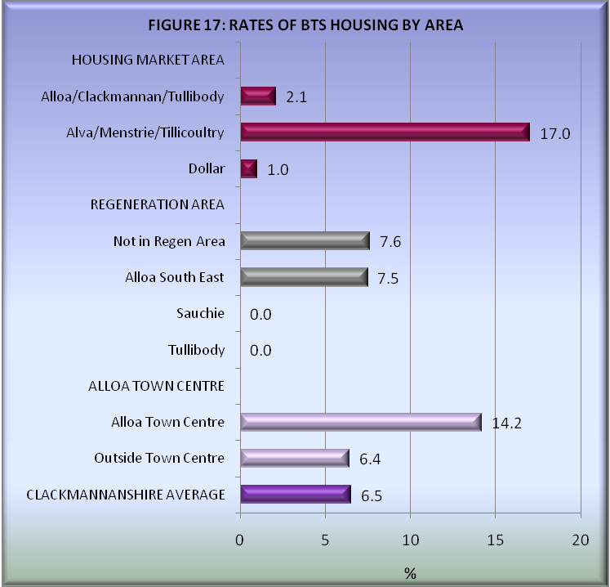
Source: Private Sector House Condition Survey 2009.

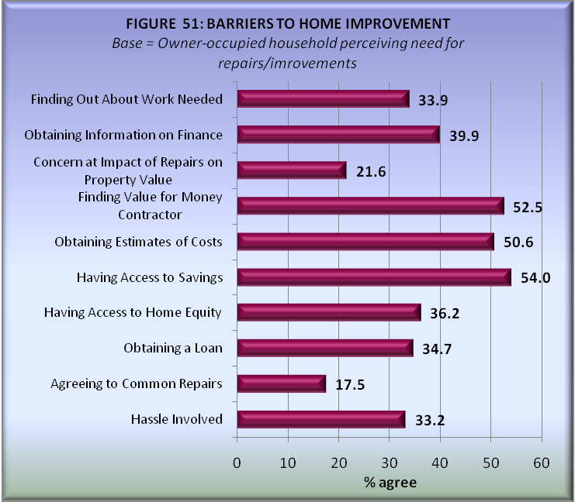
Source: Private Sector House Condition Survey 2009.

People are often discouraged from doing maintenance and repair work due to various reasons, one of the most common reasons is finding a value for money contractor.
Supporting Documents

Housing Need and Demand Assessment (HNDA)

Private Sector House Condition Survey, 2009

Public Sector House Condition Survey, 2010

This figure may now be higher, as more landlords have officially registered.
Council Tax Records.
Clackmannanshire Council Private Sector House Condition Survey 2009, David Adamson & Partners Ltd, May 2010.
Research & Information, Monthly Unemployment Claimant Count Trends, May 2010.
2008 Based Population Projections., (C) Crown copyright. Data supplied by General Register Office for Scotland.
Household Projections for Scotland, 2008 based, (C) Crown copyright. Data supplied by General Register Office for Scotland.
Private Sector Stock Condition Survey, 2010.

